**Abstract**

Food Ordering System is proposed for simplifies the food ordering process. This System shows an user interface and update the menu with all available options so that it eases the customer work. Customer can choose more than one item to make an order and can view Order details before logging off. The order confirmation is sent to the customer. The order is placed in the queue and updated in the Database and returned in real time. This system assists the staff to go through the orders in real time and process it efficiently. Online food order system is mainly designed primarily function for use in the food delivery industry. This system will allow hotels and restaurants to increase online food ordering such type of business. The customers can be selected food menu items just few minutes. In the modern food industries allows to quickly and easily delivery on customer place. Restaurant employees then use these orders through an easy to delivery on customer place easy find out navigate graphical interface for efficient processing.

**Table of Contents**

**Abstract………………………………………………………………………………. i**

**Table of Contents…………………………………………………………………….. ii**

**List of Figures………………………………………………………………………… iii**

Chapter:1 |**Introduction……………………………………………………………….01-03**

* 1. Introduction
  2. Objectives
  3. Motivation
  4. Problem Analysis
  5. Audience
  6. Contribution

Chapter:2 |**LiteratureReview……………………………………………………………04-05**

2.1 Introduction

2.2 Foodpanda

2.2.1 System Features

2.2.2 Strengths and Innovations

2.2.3 Challenges

2.2.4 Disadvantage

2.3 Uber Eats

2.3.1 System Features

2.3.2 Strengths and Innovations

2.3.3 Challenges

2.3.4 Disadvantage

Chapter:3 | **Methodology…………………………………………………………………06-08**

3.1 Admin Panel

3.2 User Panel

3.3 system Design

Chapter:4 | **Result Analysis………………………………………………………………09-11**

4.1 Login page

4.2 Home Page

4.3 Search Record,Delect Record,view Record

4.4 Food Menu

4.5 Payment

4.6 About Us

Chapter:5 |**Conclusion……………………………………………………………………12-13**

5.1 Efficiency

5.2 Limitation

5.3 Future Work

**References…………………………………………………………………………………14**

**List of Figures**

**SL.No. Figure Name Page**

**Figure-01 Admin Diagram 06**

**Figure-02 User Diagram 07**

**Figure-03 System Diagram 08**

**Figure-04 Login Page 09**

**Figure-05 Home Page 09**

**Figure-06 Search,Delect,View,Record Page 10**

**Figure-07 Food Menu Page 10**

**Figure-08 Vegetarian Menu Page 10**

**Figure-09 Non vegetarian Menu Page 11**

**Figure-10 Order Page 11**

**Figure-11 Payment Method Page 12**

**Figure-12 About us Page 12**

**CHAPTER 1**

**INTRODUCTION**

**1.1 Introduction**

The Food Ordering System can be defined as a simple and convenient way for customers to purchase food online, without having to go to the restaurant. This system is enabled by the internet – it is the internet that connects the restaurant or the food company on one hand, and the customer on other hand.Therefore, as per this system, the customer visits the restaurant’s website, browses through the various food items available there and goes ahead and selects and purchases the items he or she needs.These items will then be delivered to the customer at his or her doorstep at the time they choose by a delivery person. Payments for such online orders can be made through debit cards, credit cards, cash or card on delivery, or even through digital wallets.This system for food delivery is completely safe, secure and is a very popular method that is revolutionizing the way in which the food industry operate.Here we Propose an “ Food Ordering System” that has been Designed for Fast Food order, Take-Out or College Cafeterias. The system can also be used in any food delivery industry. This simplifies the process of food ordering for both the customer and the restaurant, as the entire process of taking orders is automated.

The main advantage of my system is that it greatly simplifies the ordering process for both the customer and the restaurant. When the customer visits the ordering webpage, they are presented with an interactive and up-to-date menu, complete with all available options and dynamically adjusting prices based on the selected options. After making a selection, the item is then added to their order, which the customer can review the details of at any time before checking out.

**1.2 Objectives**

The proposed system is developed to manage ordering activities in fast food order. It helps to record customer submitted orders. The system should cover the following functions in order to support the restaurant’s business process for achieving the objectives:

* To allow the customer to make order, view order and make changes before submitting their order and allow them make payment through cash, Bkash, Nagad or credit card or debit card.
* To provide interface that allows promotion and menu.
* To prevent interface that shows customers’ orders detail to front-end and kitchen staffs for delivering customers’ orders
* Tools that generate reports that can be used for decision making
* A tool that allows the management to modify the food information such as price, add a new menu and many others as well as tools for managing user, system menu and promotion records.

This will minimize the number of employees at the back of the counter.

The system will help to reduce labor cost involved.

The system will be less probable to make mistake, since it’s a machine.This will avoid long queues at the counter due to the speed of execution and number of optimum screens to accommodate the maximum throughput.

The main objective of the Online Food Ordering System is to manage the details of Item Category, Food, Delivery Address, Order. The purpose of the project is to build an application program to reduce the manual work for managing the Item Category, Food, Customer, Delivery Address.

**1.3 Motivation**

The motivation to develop a **food order system using C programming** arises from the simplicity, flexibility, and control offered by the C language. Implementing such a system in C demonstrates the language's capabilities in creating efficient and performance-driven solutions for real-world applications. This system specifically e made for or following issues

* It reduce manual work.
* The online food delivery system is overcome the problems in manual system.
* This system is fully computerized.
* It is user friendly.
* Provide quickly reports.
* Highly efficient and accurate.
* Prevention of unauthorised access of data.
* Automated.

**1.4 Problem Analysis**

* Some of the major problems reported by the customers surveyed revolved around late deliveries because of network problem
* Incorrect orders being delivered due to communication problem.
* Orders not being delivered at all, rude customer service.
* Cold food being delivered, and the driver requiring a lot of guidance to find the delivery location.
* Sometime payment issue is occurred.
* Online food ordering system service now days increase your budget.
* Lack of a visual confirmation that the order was placed correctly.

**1.5 Audience**

The intended audience for this system includes:

1. **Customers**: Individuals who use the system to order food for delivery or pickup.
2. **Restaurants**: Owners and managers who use the system to receive, process, and

track customer orders.

1. **Delivery Personnel**: Workers who rely on the system for order details and optimized delivery routes.
2. **System Administrators**: IT professionals who maintain the platform, manage user accounts, and resolve technical issues.
3. **Developers and Researchers**: Students, developers, or researchers interested in studying or improving food ordering systems.

**1.6 Contribution**

This project contributes to the field of software development and the food service industry by:

1. **Providing a User-Centric Solution**: The system enhances the food ordering experience for customers with easy navigation, customization, and real-time updates.
2. **Automating Restaurant Operations**: By automating order management and integrating inventory tracking, the system reduces manual errors and boosts efficiency.
3. **Supporting Delivery Personnel**: Clear instructions and optimized routes help delivery personnel save time and resources.
4. **Advancing Learning in C++**: The project demonstrates practical applications of C++ programming, including object-oriented design, file handling, and data processing.
5. **Fostering Innovation**: Encourages further development of food ordering systems with additional features like AI-driven recommendations, multi-language support, and eco-friendly initiatives.

**CHAPTER 2**

**LITERATURE REVIEW**

**2.1 Introdruction**

This section reviews the related works of Foodpanda and uber Eats, two popular online food ordering platforms. Their system have transformed the way consumers interact with restaurants ,setting a benchmark in the food delivery industry.

**2.2 FoodPanda**

Foodpanda founded in 2012, operates in multiple countries and provides a platform where customers can browse, order, and receive food from local restaurants. Its success is attributed to several key factors:

* + 1. **System Features**
* **User-friendly Interface:** Foodpanda's app and website are designed to simplify browsing, selecting, and ordering food.
* **Restaurant Integration:** The system allows restaurants to manage menus, promotions, and orders directly.
* **Real-time Tracking:** Customers can track the delivery status, from food preparation to arrival.

**2.2.2 Strengths and Innovations**

* **Diverse Cuisine Options:** Foodpanda focuses on partnering with local restaurants to cater to diverse tastes.
* **Promotions and Discounts:** It frequently uses promotional campaigns to attract and retain customers.
  + 1. **Challenges**
* **Logistical Issues:** Delivery delays due to traffic and weather conditions can lead to negative customer experiences.
* **Commission Costs:** Restaurants often express concerns about high commission fees, impacting their profitability.

**2.2.4 Disadvantage**

* **Limited Coverage in Rural Areas:** Foodpanda’s operation are often focused on urban areas, leaving rural communities underserved.
* **Customer service complaints :** users frequently report difficulties in resolving disputes ,such as incorrect orders or refunds ,due to slow or unresponsive customer service.

**2.3 Uber Eats**

Launched in 2014, Uber Eats leverages the infrastructure of Uber's ride-hailing services to facilitate food delivery. It is renowned for its innovative approach to logistics and customer service.

* + 1. **System Features**
* **Dynamic Delivery Network:** Uber Eats uses its network of drivers to optimize delivery times.
* **Customizable Menus:** Restaurants can customize menus for delivery-specific items
  + 1. **Strengths and Innovations**
* **Logistics Optimization:** Advanced algorithms match drivers with nearby orders, minimizing delivery times.
* **Global Reach:** Uber Eats operates in over 45 countries, adapting its services to local markets
  + 1. **Challenge**
* **Delivery Fees:** Customers occasionally find delivery fees high, particularly for small orders.
* **Restaurant Dependence:** Similar to Foodpanda, commission structures have drawn criticism from partnered restaurants.
  + 1. **Disadvantage**
* **Lack of Quality Control:** uber Eats has limited control over the food quality provided by restaurants and poor food quality can reflect negatively on the platform.
* **Unpredictable Delivery Times:** Despite advanced logistics, external factors like traffic congestion can still cause delays, frustrating customers.

**CHAPTER 3**

**METHODOLOGY**

A **food ordering system flowchart** provides a visual representation of the step-by-step process involved in ordering food, from the user's interaction with the system to the delivery or pickup of the order.

**3.1 Admin Panel**

**Admin**

**Figure-01:Admin Diagram**

**3.2 User Panel**

**User**

**Figure-02:User Diagram**

**3.3 System Design**

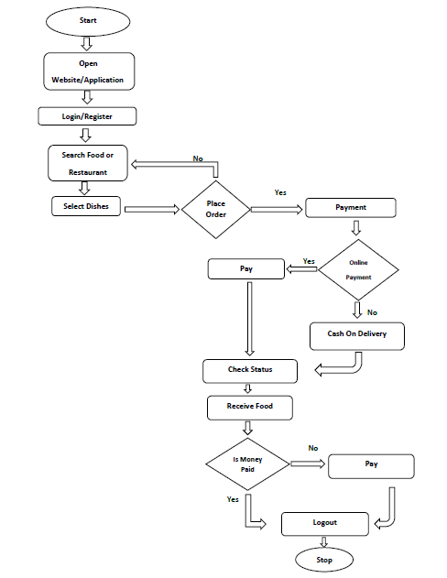

**Figure-03:System Diagram**

**CHAPTER 4**

**RESULT ANALYSIS**

**4.1 Login page**

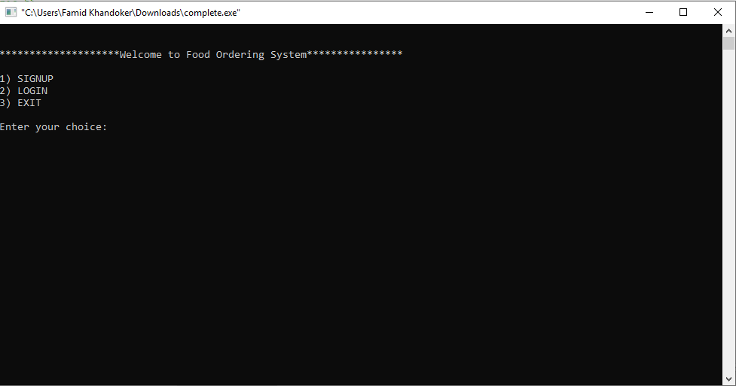

**Figure-04:Login Page**

**4.2 Home page**

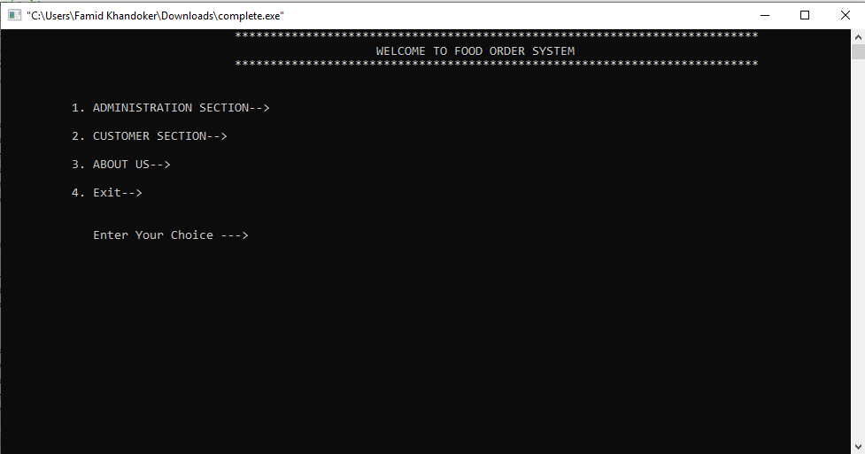

**4.3 Search Record,Delect Record,view Record**

**Figure-05: Home Page**

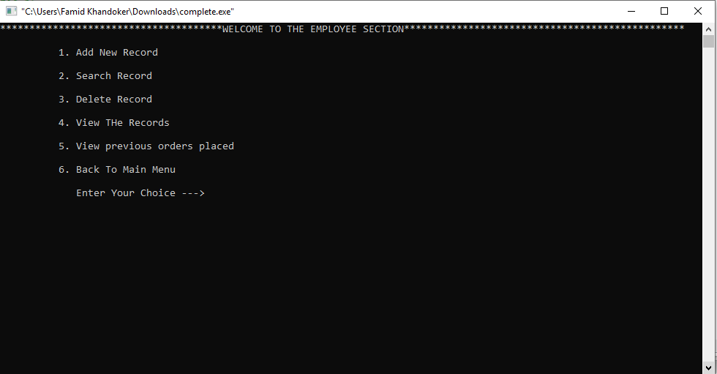**4.3 Search Record,Delect Record,view Record**

**Figure-06:Search,Delect,View,Record Page**

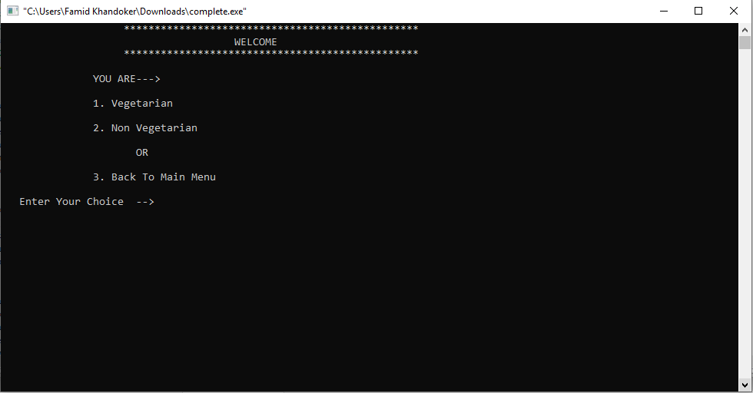**4.4 Food Menu**

**Figure-07:Food Menu Page**

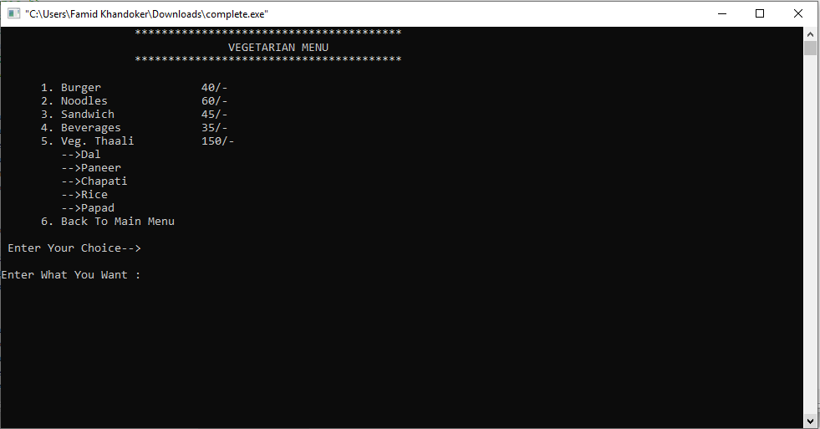

**Figure-08:Vegetarian Menu Page**

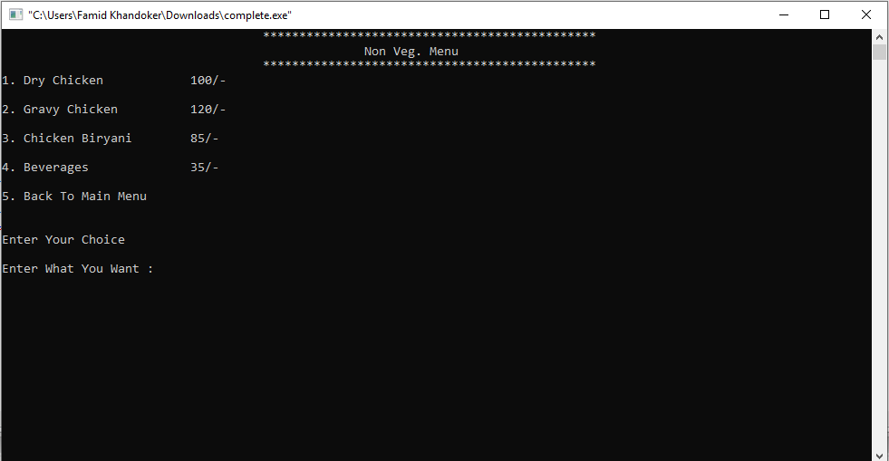

**Figure-09:Non vegetarian Menu Page**

**4.5 payment**

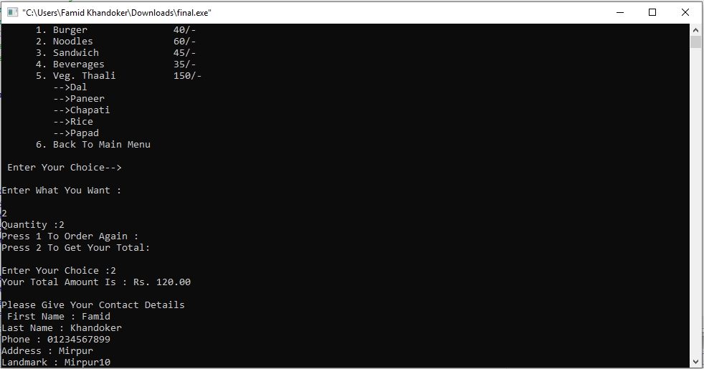

**Figure-10:Order Page**

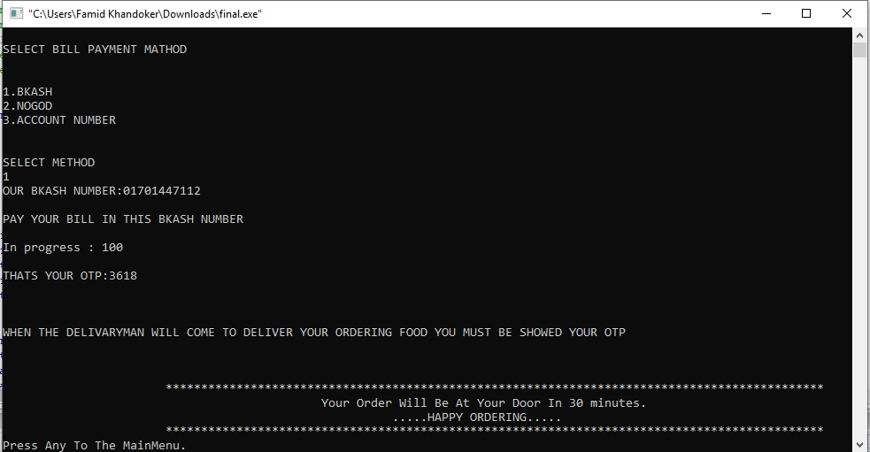

**Figure-11:Payment Method Page**

**4.6 About Us**

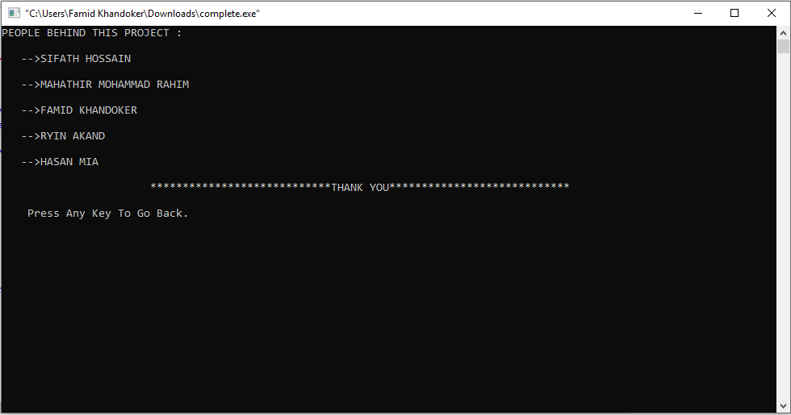

**Figure-12:About us Page**

**CHAPTER 5**

**CONCLUSION**

**5.1 Efficiency**

The C++ food ordering system efficiently handles basic order processing tasks, including menu management, order placement, and payment calculation. By leveraging structured programming techniques and efficient algorithms, the system ensures quick response times and minimizes computational overhead. The use of file handling allows persistent data storage for menu details and order history, while modular design simplifies code maintenance and debugging.

**5.2 Limitation**

Due to manual means being employed by the fast food restaurants, it is very difficult to satisfy the wants and needs of the customers. Most of the problems include:

* Mistakes are made when taking the orders of the customers
* The process of collecting customers’ purchases order is very tedious. This makes it impossible to deliver goods on time.
* It leads to lack of understanding between the customers and the employees.
* The record keeping system is poor. Losses of vital records have been reported in the past consequently.
* Besides, protecting the file system from unauthorized access is a problem that has defiled solution.

**5.3 Future Work**

To improve the system and enhance its usability, several enhancements can be implemented:

* **Graphical User Interface (GUI)**: Developing a GUI using frameworks like Qt or integrating it with web technologies to make it more user-friendly.
* **Database Integration**: Replacing file-based storage with a robust database system such as MySQL or SQLite for better data management and scalability.
* **Networking Features**: Introducing online ordering capabilities by enabling communication over a network, making it suitable for web or mobile applications.
* **Real-Time Inventory**: Adding a real-time inventory management module to track stock and prevent over-ordering.
* **Security Enhancements**: Implementing secure authentication and encryption techniques to safeguard sensitive user data.
* **Analytics and Reporting**: Integrating analytics features to generate insights on sales, customer preferences, and system performance.

**References**

w3 school used in c programming and Fowchart used in Draw.io, tutorials point website visit with coding syntax understanding.

Following link:

**w3schools :** <https://www.w3schools.com>

**Draw.io :** <https://app.diagrams.net>

**Tutorialspoint :** <https://www.tutorialspoint.com>